**Navi Case Study - Joe and Mary Smith**



**Case Study Workshop: Joe and Marie Smith's Retirement Planning**

Introduction: Joe and Marie Smith, a couple in their late 40s from Calgary, Alberta, are actively planning for their retirement, which they hope to enjoy when Joe reaches the age of 60. They are looking at retiring on 75% of their current net income. They have specific financial goals, assets, and a child's education to consider in their planning. This case study will walk through their financial situation and create a Navi Plan to help them achieve their retirement goals.

Client Information:

Joe Smith:

● Occupation: Self-employed electrician

● Annual Net Income: $90,000

● Date of Birth: February 1, 1976

Marie Smith:

● Occupation: Sales Manager at ABC Gadgets

● Annual Income: $75,000

● Date of Birth: March 1, 1975

Child: Theresa Smith

● Date of Birth: January 10, 2006

● RESP of $25,000 with a monthly contribution: $250. Expected University Costs for Theresa: $15,000 per year for 4 years (in today's dollars)

● CPP taken at age 65. Joe expects to receive 75% of his CPP and Marie expects to receive 80% of her CPP.

Assets:

● Home Value: $700,000

● Mortgage Balance: $400,000 with monthly payments of $3,650 with a 5% rate.

● Joe's RRSP: $125,000 with monthly contributions of $250.

● Marie's Defined Contribution Plan: $200,000 with a 4% employer matching contribution

● TFSAs (maxed): $100,000 each. 50% of Joe’s TFSA is invested in a Daily Savings account at 2% and is used for Emergency Purposes. The remaining TFSA portfolio is used for retirement purposes. They maximize their TFSA accounts each year. Joe’s future contribution will be allocated to the TFSA retirement portion.

● Joint Non-Registered Portfolio (Segregated Funds): $125,000 ACB of $115,000. *For this case study do not transfer the non-registered assets to RRSP or TFSA. The reason for this is to create a liquidation strategy for retirement purposes.*

● Life Insurance (Term 20): $100,000 each with monthly premiums of $100.

Assumptions:

● Inflation Rate: 2.1%

● Risk Profile: Moderate for both

● Mortality Assumption: Both Joe and Marie are assumed to live until the age of 95.

● Retirement Age: Joe and Marie plan to retire when Joe reaches the age of 60 (Jan 2036)

Goals and Objectives:

Ensure they have enough savings to fund Theresa's university education.

Maximize their retirement income while maintaining tax efficiency.

Review and potentially adjust their life insurance coverage to cover them until retirement in 2037.

**Steps to Create a Navi Plan:**

1. Education Planning for Theresa:

● The total cost of Theresa's education in today's dollars:

● 4 years x $15,000/year = $60,000

● Determine the future cost of Theresa's education, accounting for 2.1% inflation, plus 2%.

● Calculate the monthly contribution needed to reach this goal.

2. Retirement Savings Analysis:

● Determine if they need to adjust their retirement strategy to meet 100% of their retirement income goals.

● Create a tax efficient strategy for the liquidation of their retirement assets upon retirement.

4. Life Insurance Review:

● Review their current life insurance coverage and assess whether their coverage aligns with their financial needs until their planned retirement in 2036.

5. Retirement Income Strategy:

● Explore tax-efficient strategies to maximize retirement income.

● Consider income-splitting, RRSP withdrawals, Non-Registered and TFSA utilization to minimize tax liabilities.

By following these steps and leveraging Navi Plan, Joe and Marie Smith can create a comprehensive retirement plan that addresses their financial objectives and ensures a comfortable retirement while optimizing tax efficiency. This plan will help them navigate the path to their retirement goals with confidence.

Create a summary using the 1 Page Document with your logo attached. If you do not have this page, please e mail me and I can email you a copy.

You can also create a summary from the User Defined Text Field for Objectives, Recommendations and Action Plan. This can be seen in Navi Tips under Summary.

**Navi Solution to Case Study**

The following are the steps required to complete the plan.

1. Enter the data.
   1. Include All Assets and Liabilities
   2. Include Insurance Policies
   3. Include Education Data
2. Analyze the data.
3. Determine Surplus or Shortfall
4. Make Recommendations
5. Create Action Plan
6. Summarize with the 1 Page Summary and/or the Client Data Fields.

**Entering the Data**

Enter the data as stated in the case.

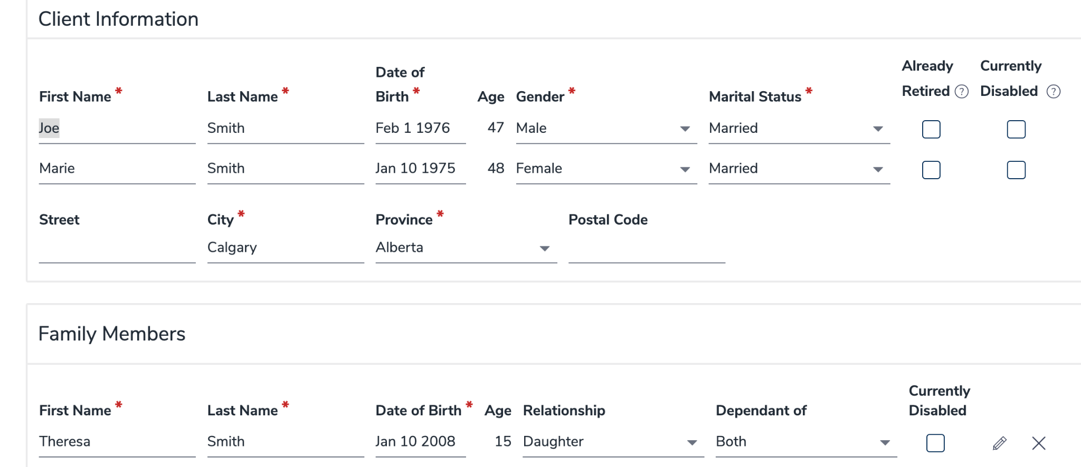

**Entering the Data**

**Entering Cash Flow**

As Joe is self-employed, the income needs to be entered as self employed.

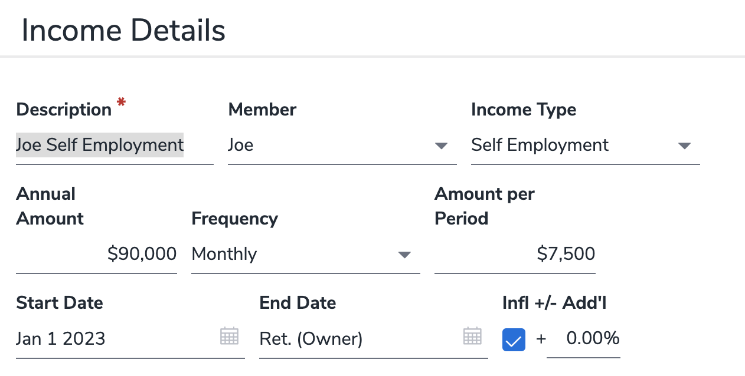

**Entering CPP Income**

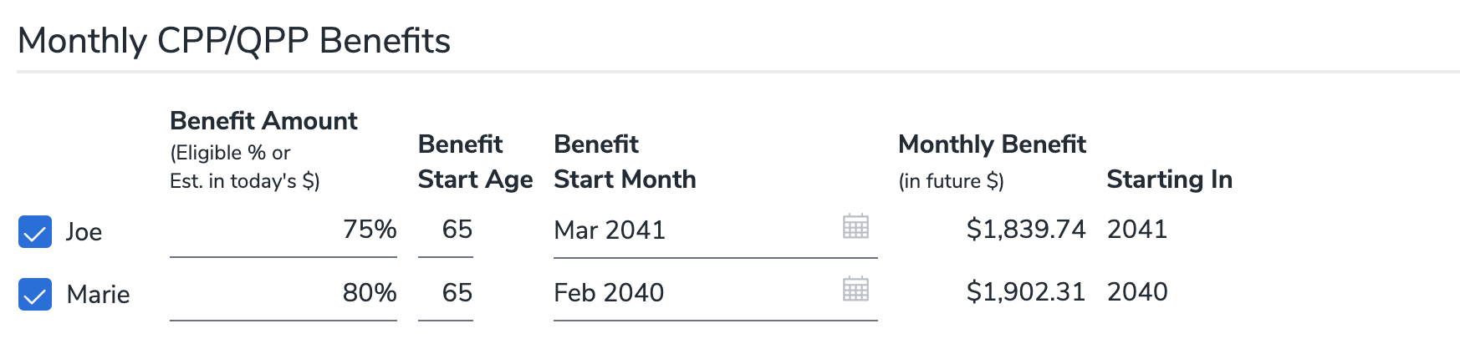

**Entering Net Worth**

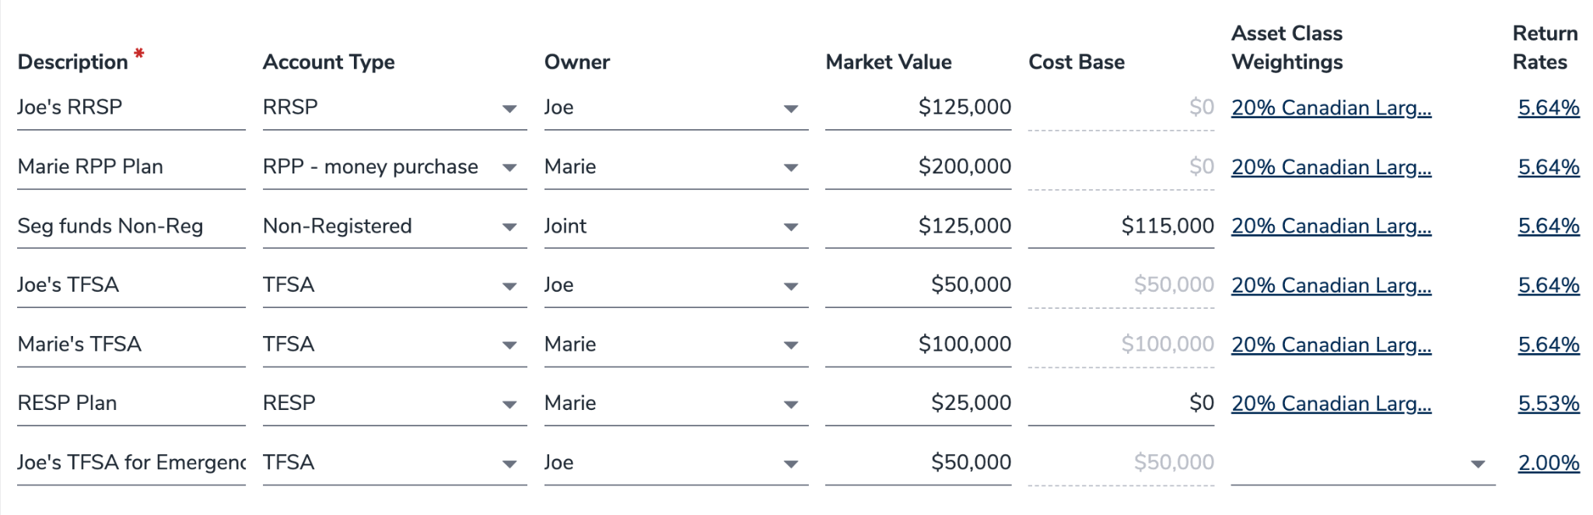

Make sure you enter the cost base of the non-registered asset. if you do not, the entire investment will be taxable. The Asset Class holdings are derived from the Moderate Profile.

**Profile**

The Smiths have a Moderate investment profile.

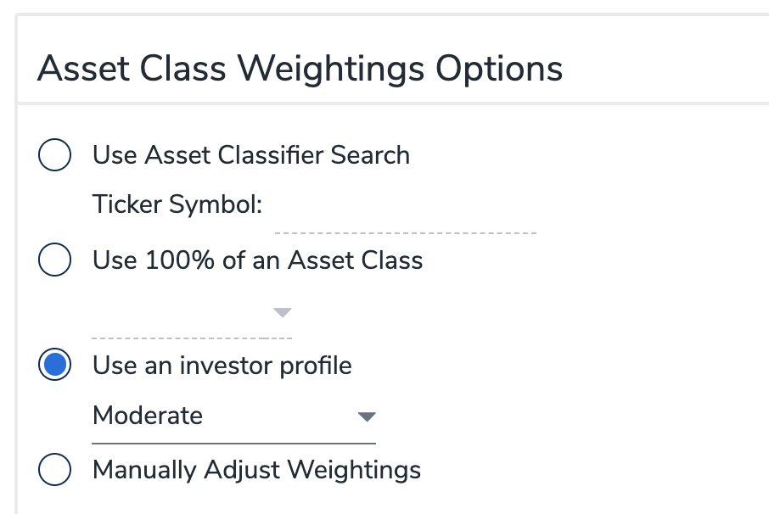

Entering Strategies

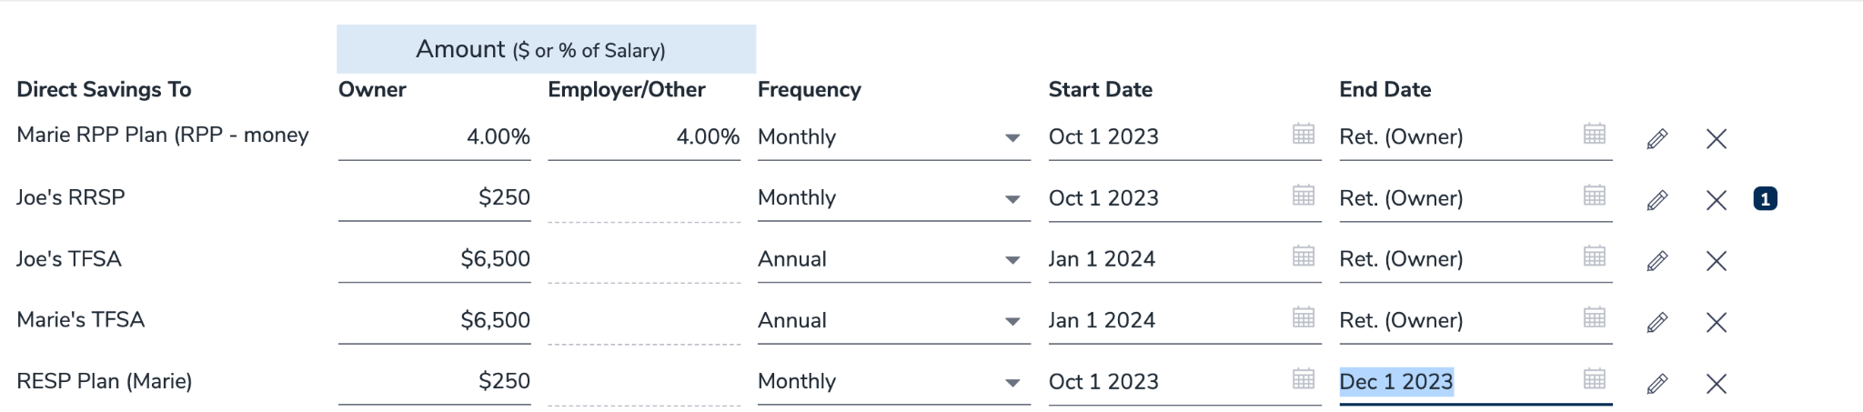

Notes, Marie’s RPP plan is 4% matching. TFSA contributions are made annually. As stated in the case study the TFSA contributions should commence in 2024. The RESP plan has $250 monthly payments until December 2023 when Theresa turns 17, payments must cease.

Enter the Goal Funding

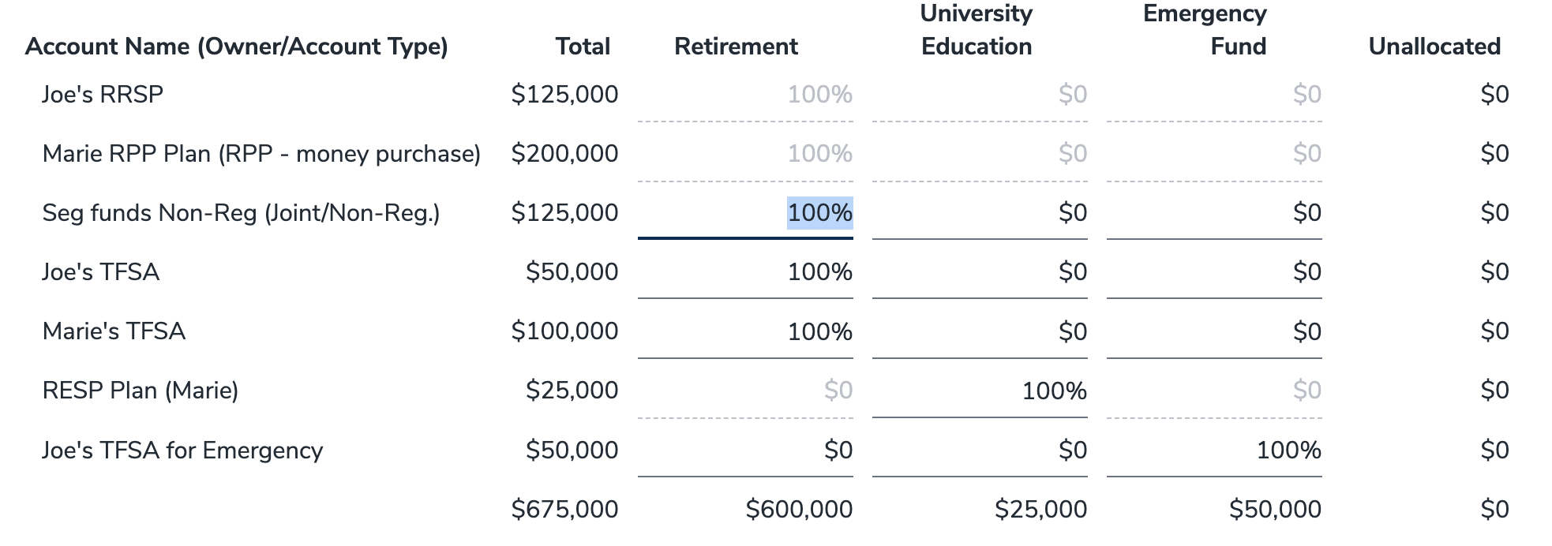

Note, modify the goal funding for Joe’s TFSA for emergency purpose to the Emergency Fund.

Entering Insurance Data

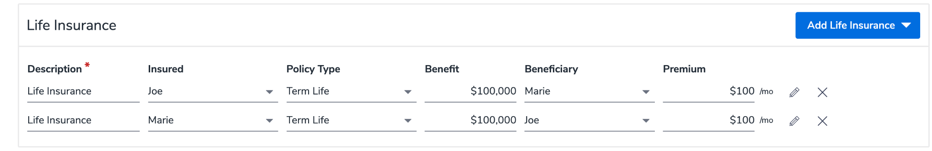

The Smiths have 2 life insurance policies for $100,000 each.

**Analyzing the Data**

Retirement

The case study stated that Joe and Mary are looking at retiring with 75% of their net income. To calculate this amount, type in 75% of their current after-tax income. Then click the blue tab marked, Add to Retirement Expenses. Your Retirement Expense should be approximately $8,328 per month.

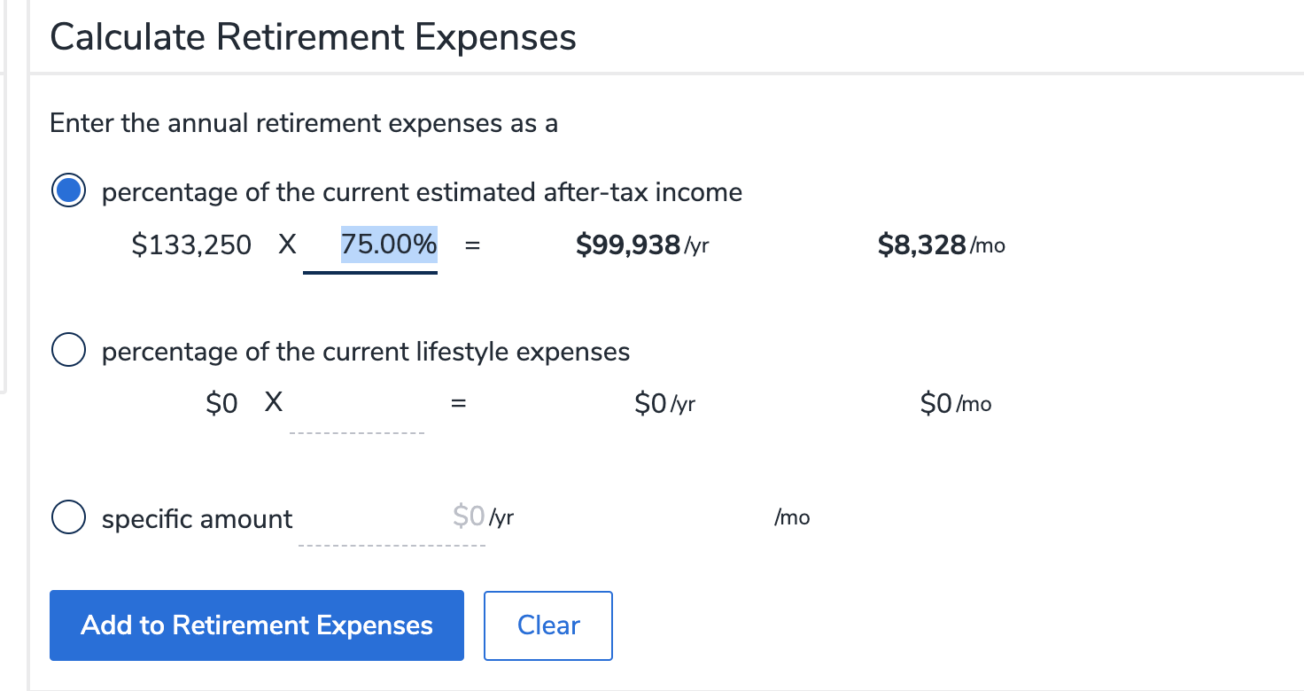

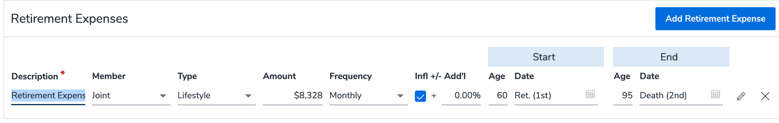

*Note, make you are using self-employment income for Joe as his net income will be less due to paying the full CPP amount.*

**Analyze Retirement Goal**

Click on Analyze Goal. You can see that they are only at 93% of their goal. You now need to create a plan that will achieve 100% of their goal.

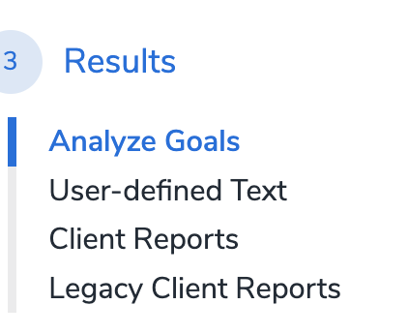



**Options for Retirement**

Review your options in Navi and in consultation with the Smith’s and derive a plan to come up with a strategy to meet their retirement goal of 100%.

For illustrative purposes, you can use the strategy of lowering expenses after the year 2050 to 65% of their current net income as follows:

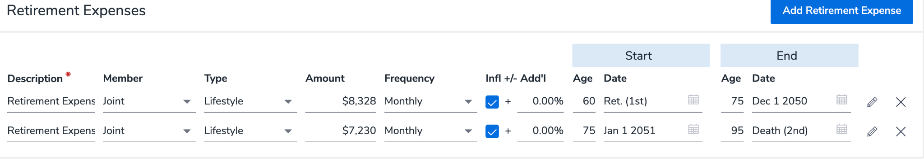

**Liquidation Strategies**

Your expertise and education as a Certified Financial Planner (CFP) play a pivotal role here. You're seeking out avenues for tax optimization, exploring strategies for income distribution, and devising methods for efficient drawdown of assets. To adjust the liquidation strategies, simply navigate to the "Retirement - Liquidation Strategies" section and select "View Modify". This is where your specialized knowledge and experience come into play, ensuring the most effective financial planning for your clients.

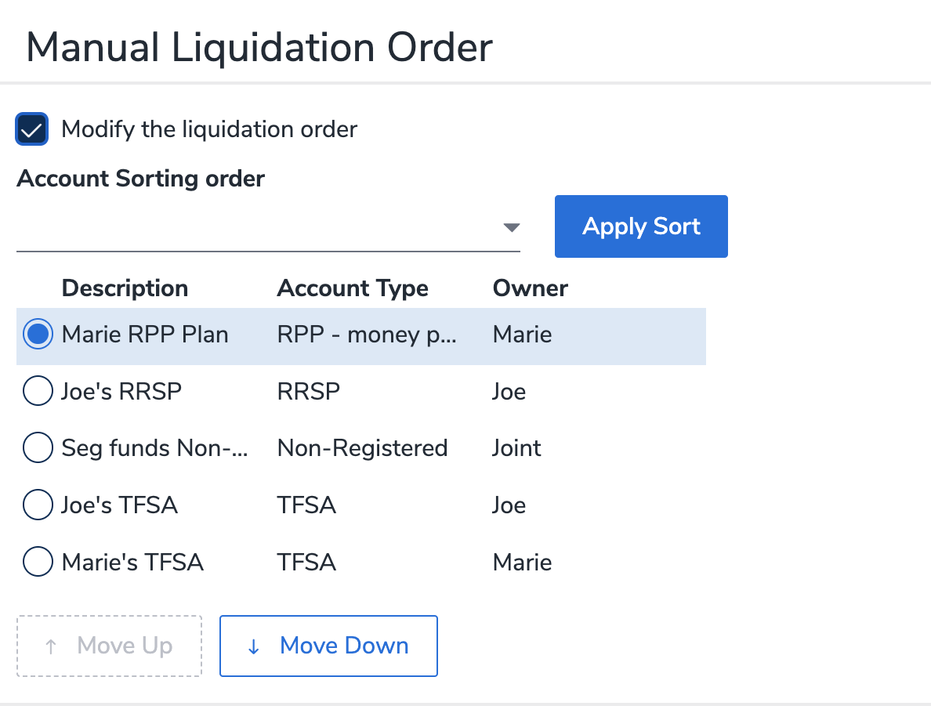

To split income prior to age 65, you will need to use the Registered Set Up for Marie’s RPP plan. Convert to LIF at Retirement, Elect Payout in first year and use the Maximum Payout as follows:

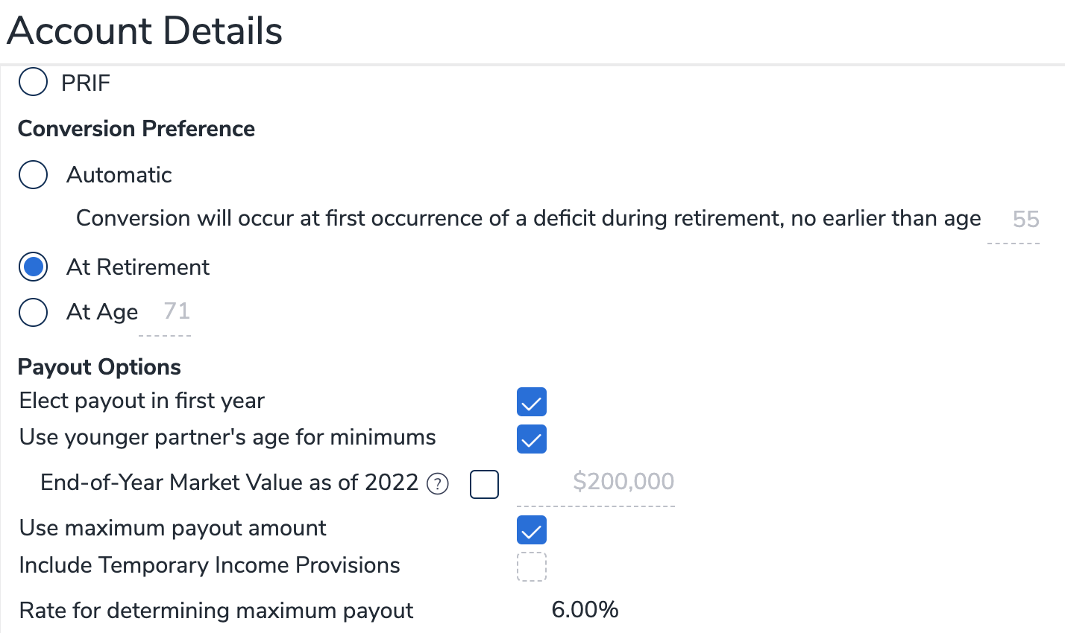

There is a heavy tax burden due to the registered assets being liquidated. **One strategy to decrease the tax liabilities is to blend nonregistered assets with the registered assets.**

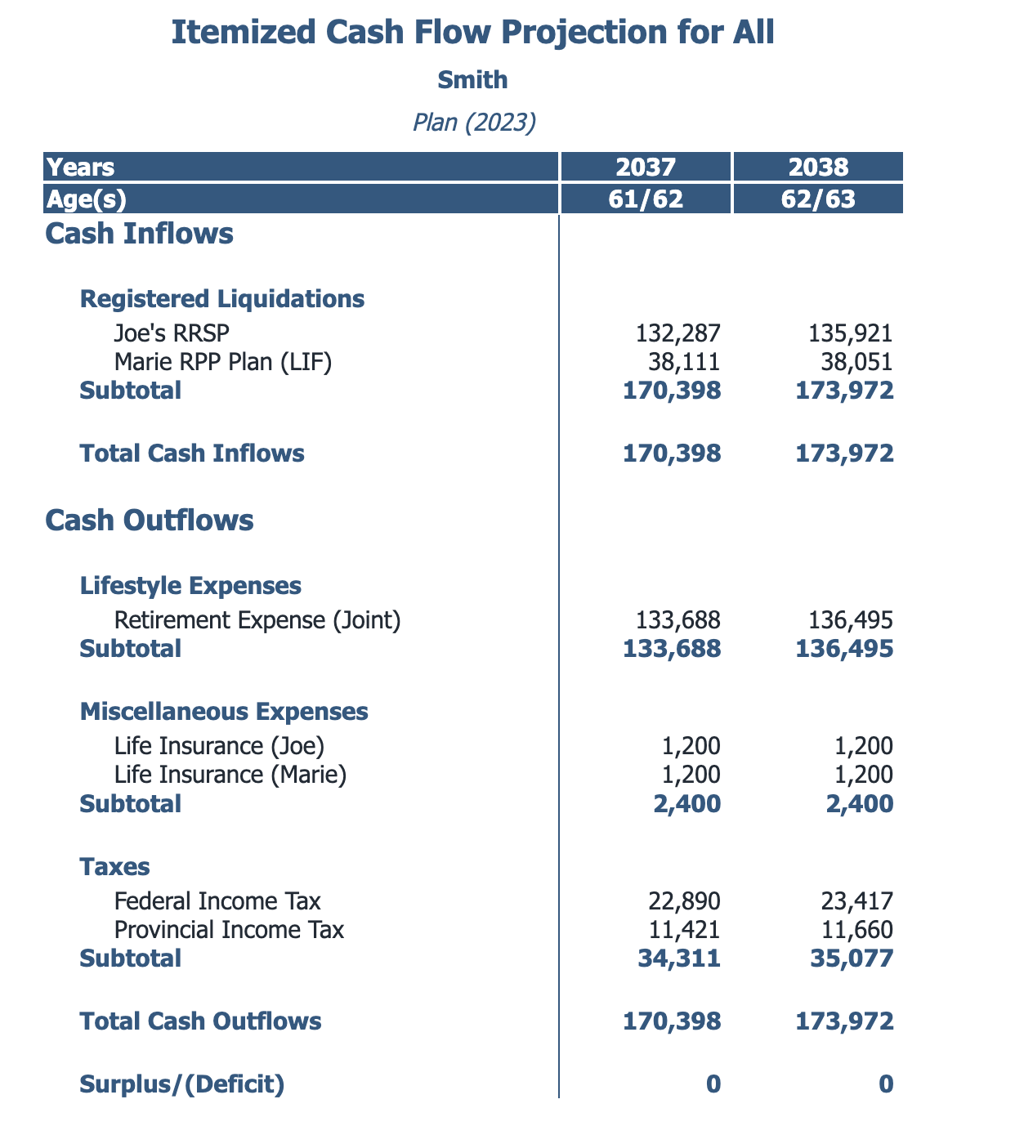

By redeeming 10% each year of the non-registered assets, the tax liability has been reduced significantly.

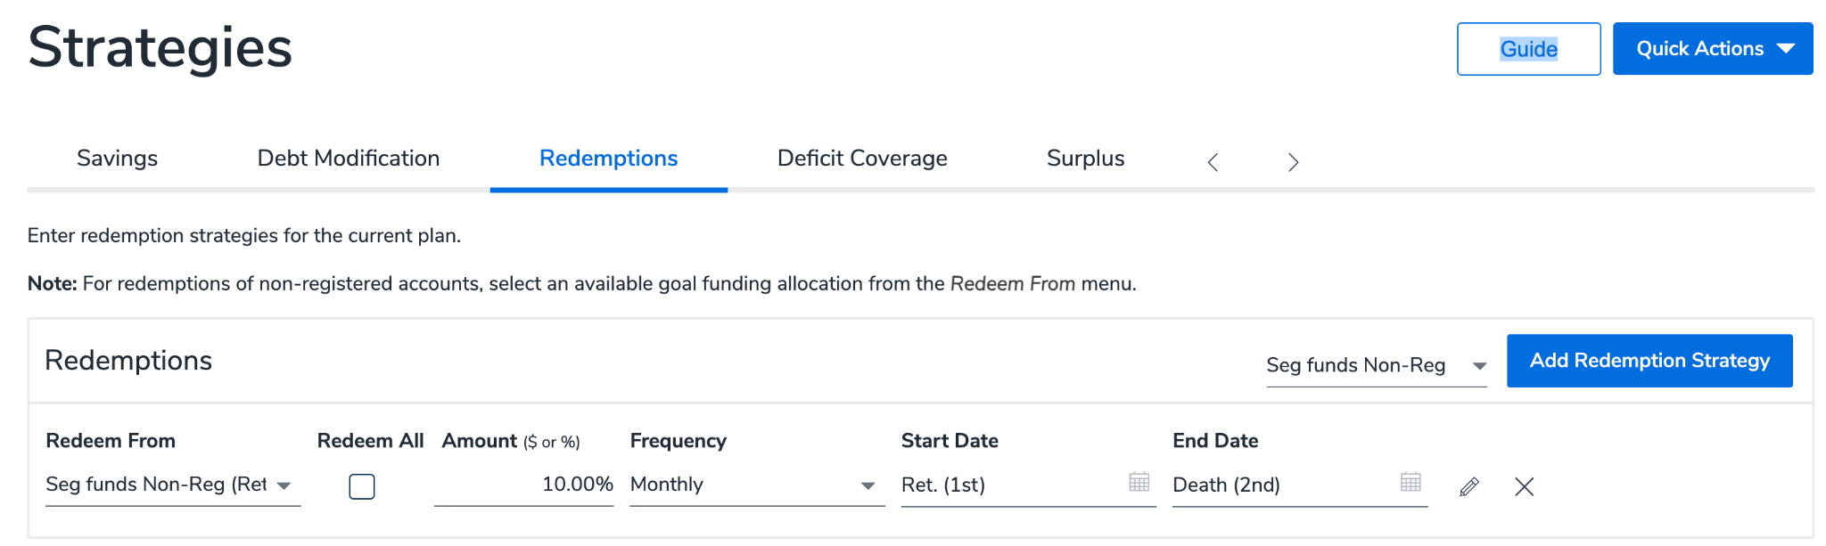

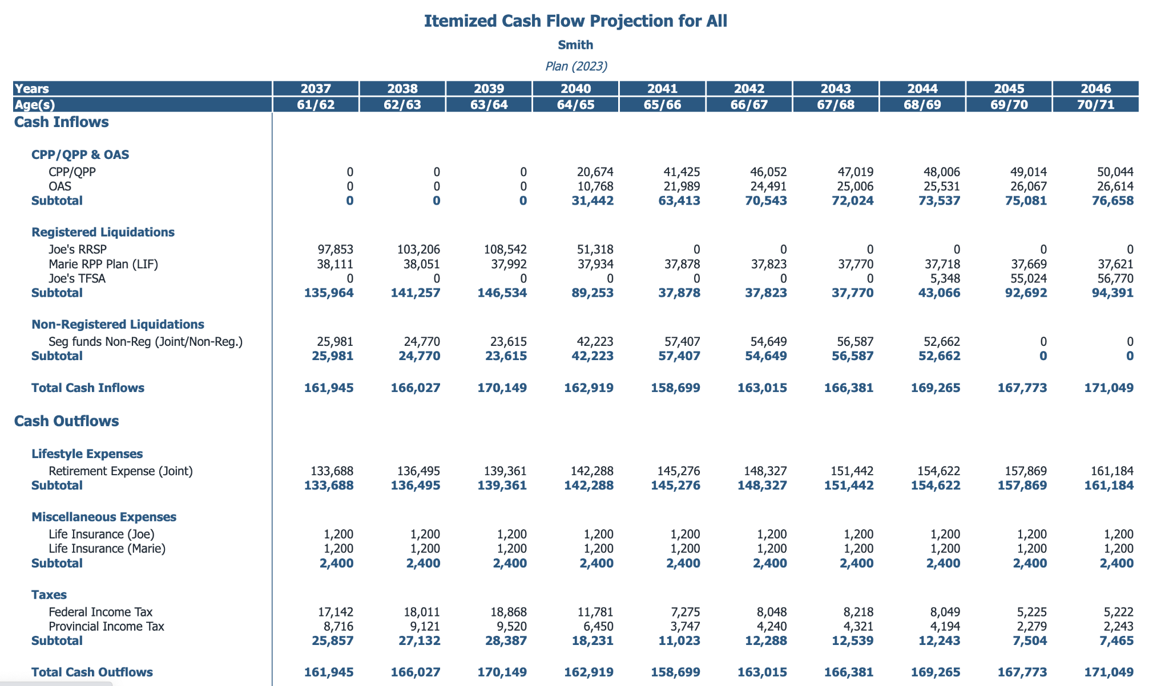

With the new strategy of blending the non-registered assets, approximately $10,000 has been reduced from the tax liabilities.

**Education Analysis**

The purpose of this exercise is to determine what the gap is between their current savings and the future cost of education.



There is a shortfall of approximately $40,000.

**Survivor Income**

**Quick Assessment**

To commence the Survivor Income Analysis, Open the Module for Survivor Income.

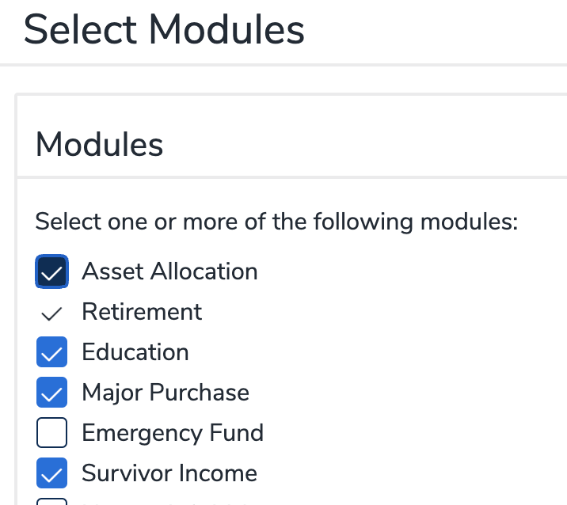

The following steps will explain the Survivor Needs Analysis

1. **Lump Sum Needs**. The lump sum needs of the Smith’s is the Mortgage the education shortfall and final burial expenses (this will vary with each member). Total final expenses are $471,939.
2. **Ongoing Needs**. The ongoing needs, future income required to sustain the same lifestyle. Click on the Box beside years.

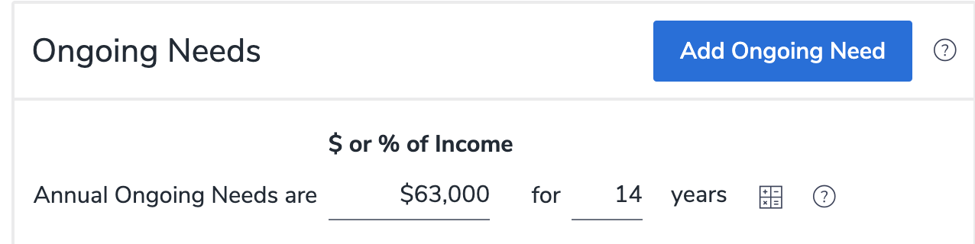

Determine the number of years the net income is required. In this case it is 14 years calculated as (Year expected to retire of 2037 less the current year of 2023). There is an estimated tax rate of 30% to determine the net income (this can vary depending on the income).

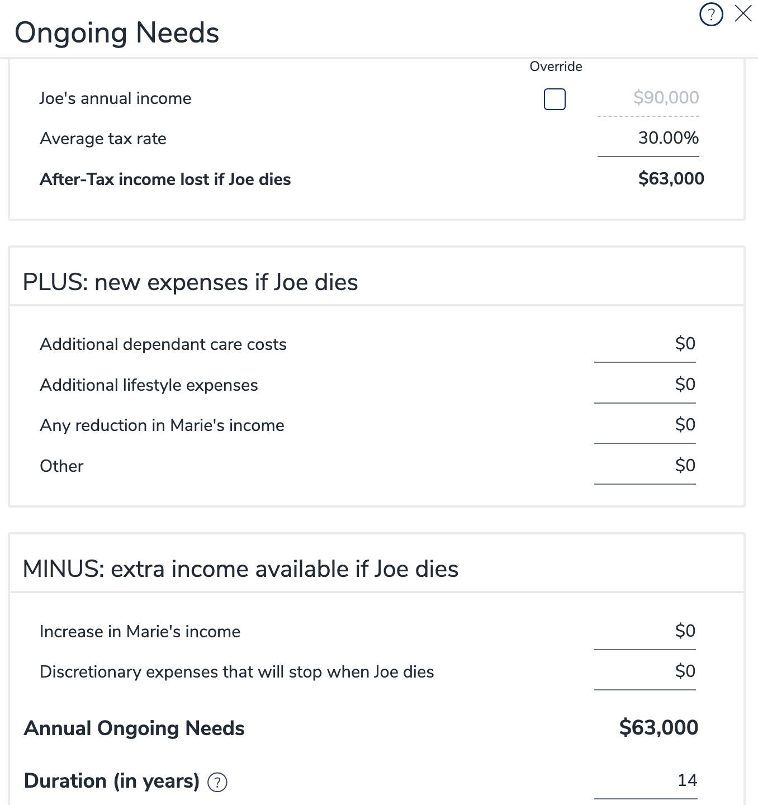

1. **Available Assets Override**. A recommendation is to try to avoid selling assets for the surviving spouse to make ends meet. Click on Available Assets Override and 0 out the realizable assets. The existing life insurance policy will be remaining.

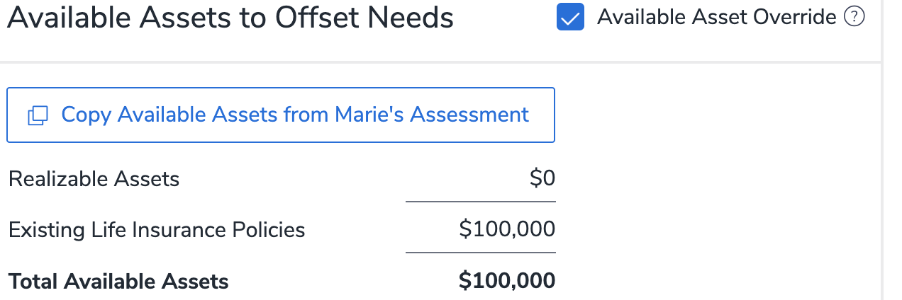

1. Review the results. The Smiths have the following insurance requirements based on our analysis.
   1. Lump sum needs of $471,939 including the mortgage, education funding and final expenses.
   2. Ongoing income needs for Marie of $797,560. Note this is the amount to replace Joe’s net income for 14 years using an inflation rate of 2.1% and 5% Rate of Return.
   3. Available assets represents the insurance policy. Ongoing incomes represent the future CPP/OAS for Marie.
   4. There is additional life insurance needed of approximately $1 million.

**Variables for Consideration.**

The above analysis is a ‘Quick Assessment’. When this analysis is referred to a life insurance agent, a more detailed analysis is performed. Other factors to consider are:

1. The expense that will no longer be required by the deceased based on personal consumption expense.
2. The surviving spouse assumes the same expenditures even after debts are paid off. This may be further altered after a detailed analysis is performed by the life insurance representative.

This comprehensive strategy considers several elements, such as self-employment earnings, RPP unlocking, liquidation approaches, RESP evaluation, and survivor income considerations. Given the multifaceted nature of this plan, focusing on each component individually will lead to a well-coordinated outcome. Providing your member with a concise one-page summary in your presentation will be instrumental in presenting the plan in a condensed yet detailed manner.

Happy planning, and as always, feel free to reach out to me if you have any questions.

Sheldon Craig, CFP®

Regional Manager

[scraig@cuwealth.ca](mailto:scraig@cuwealth.ca)

CUSO Wealth Strategies Inc.